EX NO:1 | Butterworth IIR Filters
DATE: | 1.1. Design and Analysis of a Butterworth IIR Low-Pass Filter Using  MATLAB.

Program (Matlab Code);
clc; clear
Fs=10000; Fp=1000; Fst=1500;
[N,Wn]=buttord(Fp/(Fs/2),Fst/(Fs/2),1,60);
[b,a]=butter(N,Wn);
freqz(b,a) % Magnitude & Phase
figure
[h,n]=impz(b,a,50);
...title('Impulse Response')
figure
stepz(b,a)
figure
zplane(b,a)
fprintf('Minimum Filter Order (N) = %d\n',N);
fprintf('Cutoff Frequency (Wn) = %.4f\n',Wn);

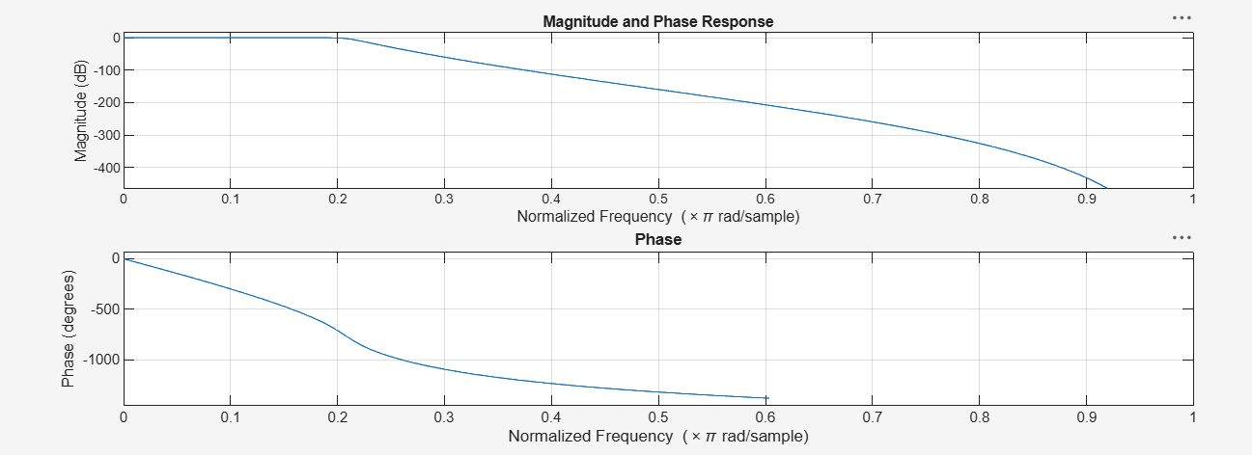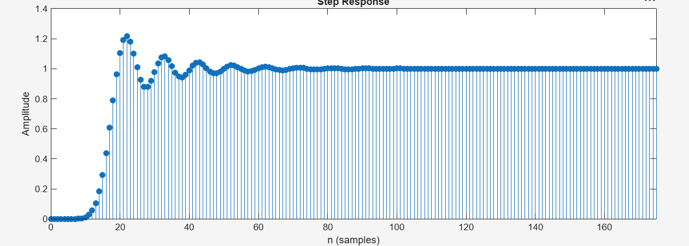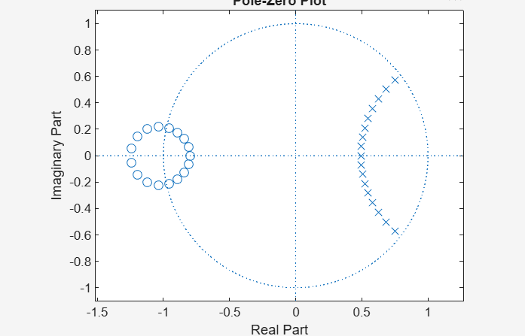

EXPT 1 | Butterworth IIR Filters
DATE: | 1.2. Design and Analysis of a Butterworth IIR High-Pass Filter Using  MATLAB.

Program (Matlab Code):
clc; clear
Fs=10000; Fp=3000; Fst=2000;
[N,Wn]=buttord(Fp/(Fs/2),Fst/(Fs/2),1,60);
[b,a]=butter(N,Wn,'high');
% Magnitude & Phase
freqz(b,a)
% Impulse Response
figure
[h,n]=impz(b,a,50);
stem(n,h), grid on
title('Impulse Response')
% Step Response
figure
stepz(b,a)
title('Step Response')
% Group Delay
figure
grpdelay(b,a)
title('Group Delay')
% Pole-Zero Plot
figure
zplane(b,a)
title('Pole-Zero Plot')
fprintf('Minimum Filter Order (N) = %d\n',N);
fprintf('Cutoff Frequency (Wn) = %.4f\n',Wn);

